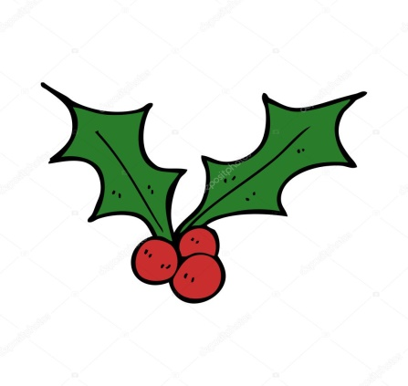 HAMPER DONATIONS LIST
Prosecco
Bucks Fizz
White wine
Red wine
Rose wine
Port
Sherry
Baileys
Tins of sweets
Chocolates
Florentines
Nuts
After Eights
Mince pies
Christmas cake
Panatone
Ground coffee
Loose Tea
Mulled wine Spices
Pickles/Chutneys
Crackers for cheese
Festive candles
Festive tea lights
Festive reed diffuser
Christmas napkins
Christmas table accessories

