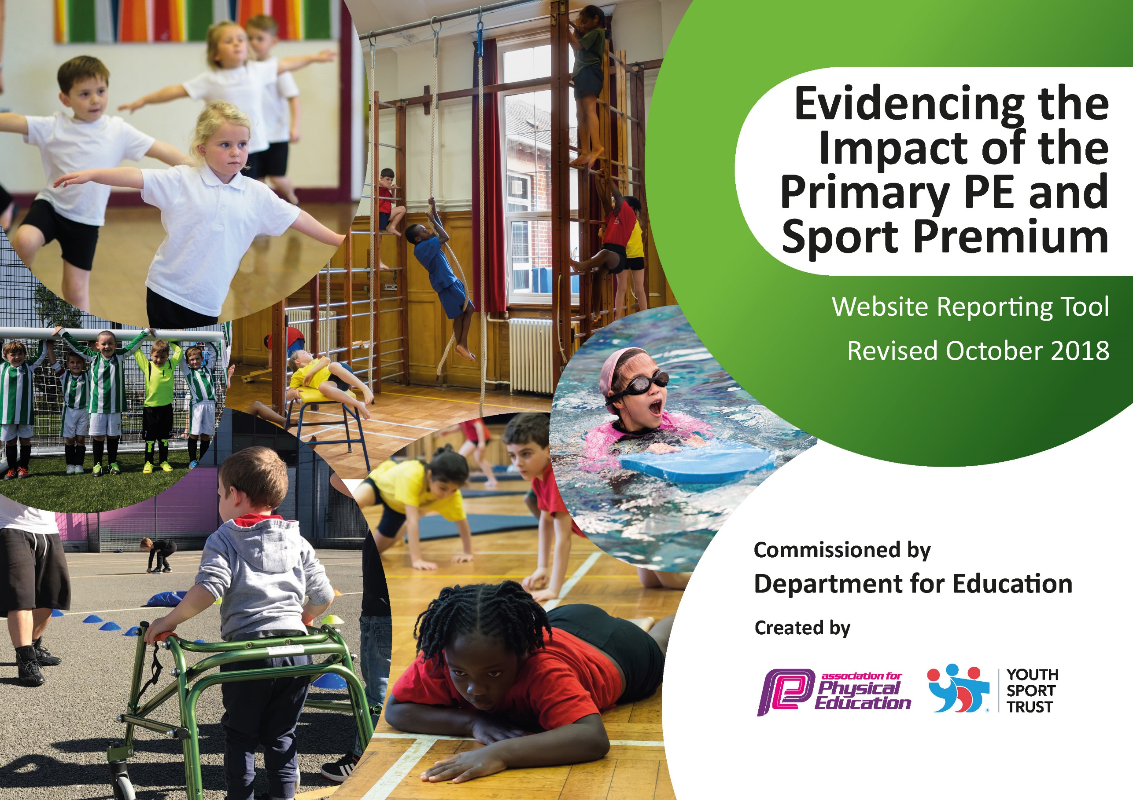
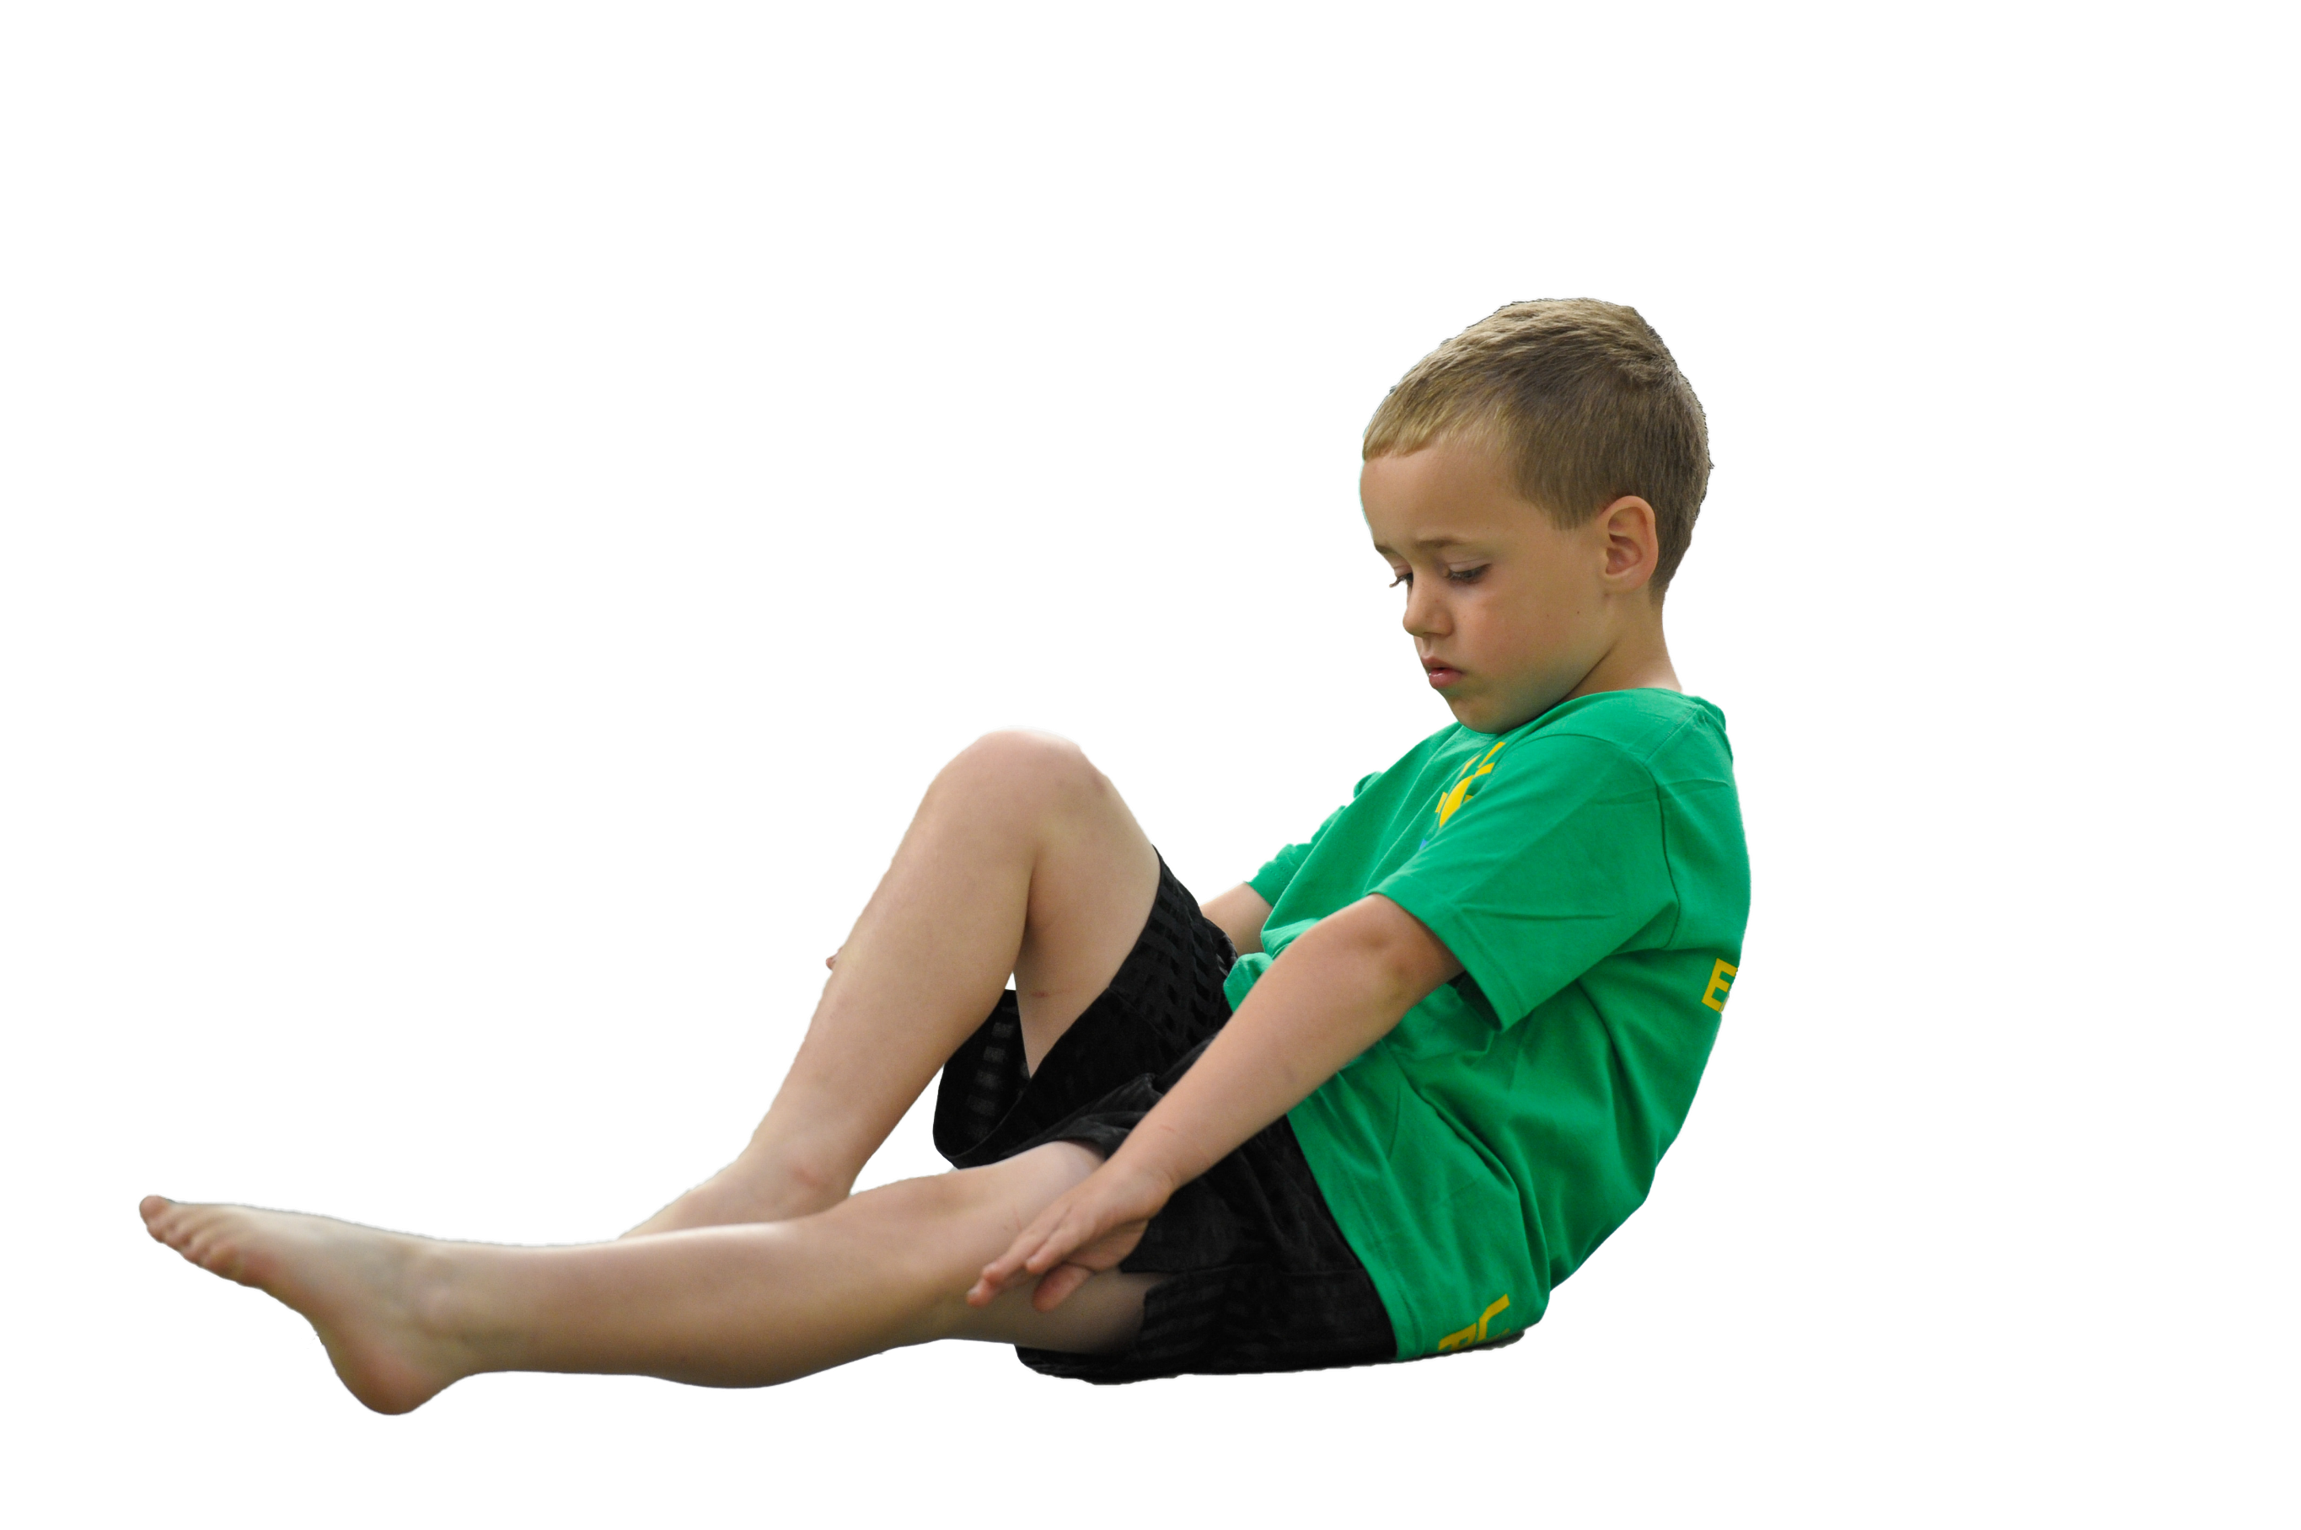
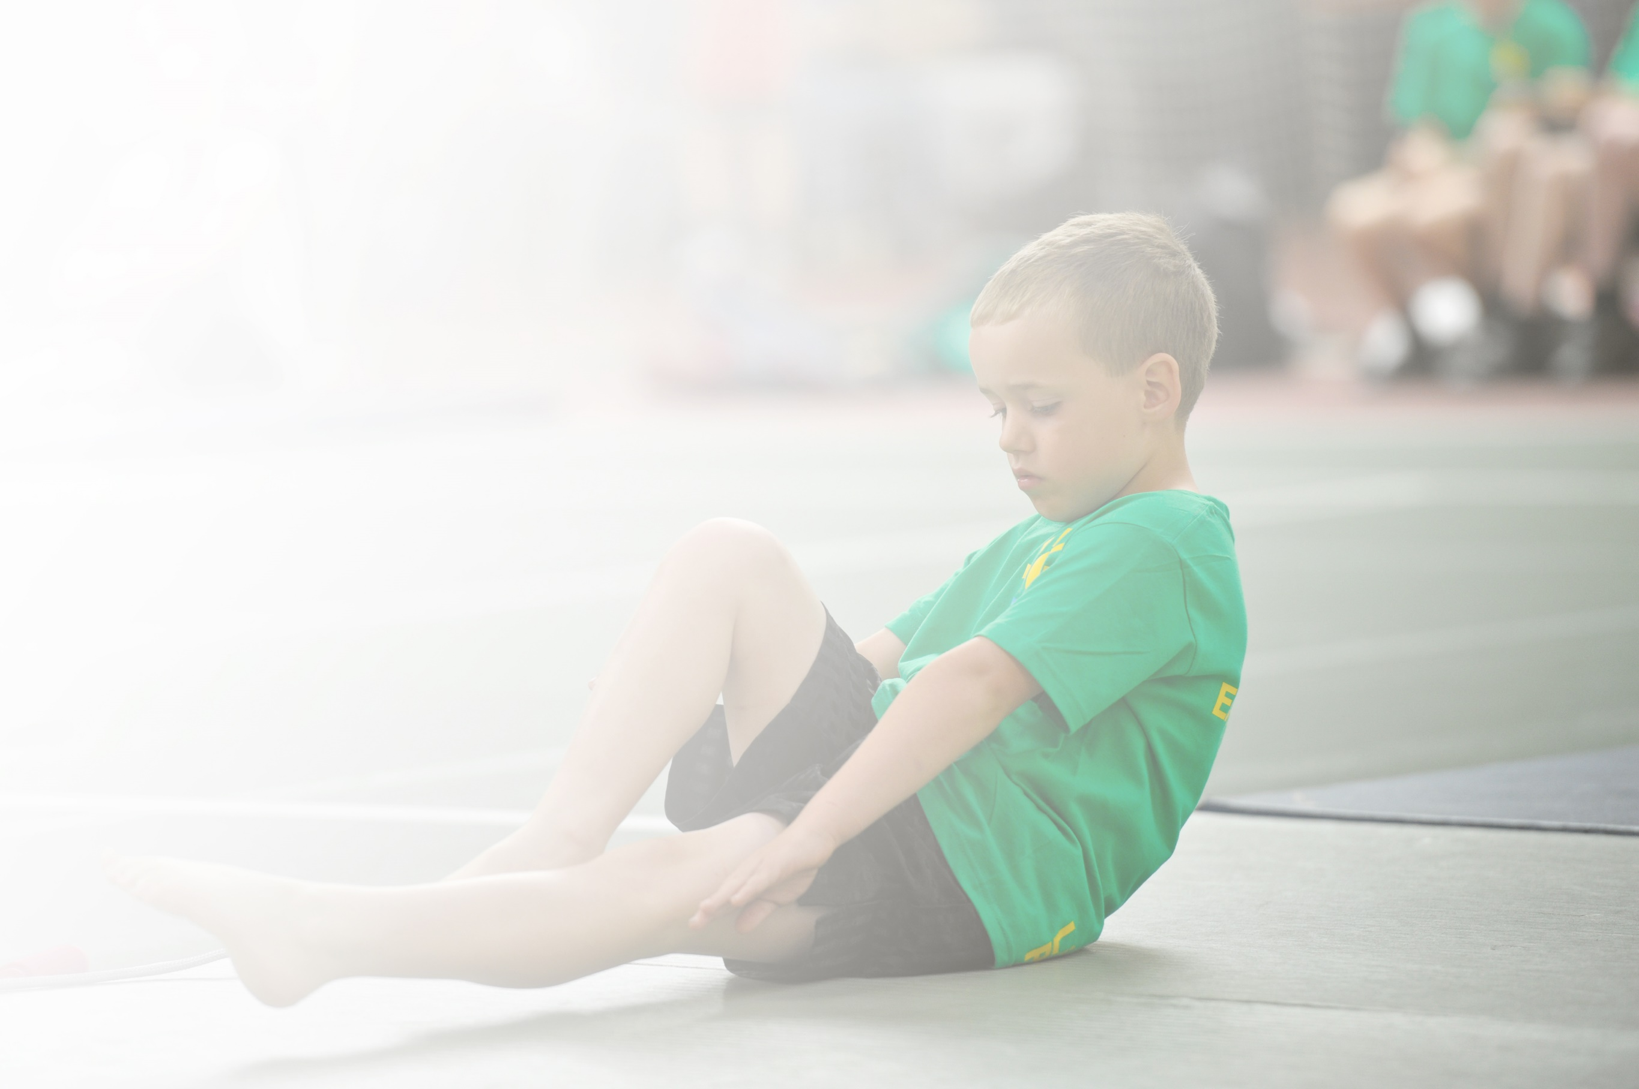
Schools must use the funding to make additional and sustainable improvements to the quality of Physical Education, Sport and Physical Activity (PESPA) they offer. This means that you should use the Primary PE and Sport Premium to:

- Develop or add to the PESPA activities that your school already offer
- Build capacity and capability within the school to ensure that improvements made now will benefit pupils joining the school in future years

Please visit gov.uk for the revised DfE guidance including the 5 key indicators across which schools should demonstrate an improvement. This document will help you to review your provision and to report
your spend. DfE encourages schools to use this template as an effective way of meeting the reporting requirements of the Primary PE and Sport Premium.

We recommend you start by reflecting on the impact of current provision and reviewing the previous
spend. Under the Ofsted Schools Inspection Framework, inspectors will assess how effectively leaders use the Primary PE and Sport Premium and measure its impact on outcomes for pupils, and how effectively governors hold them to account for this.

Schools are required to publish details of how they spend this funding as well as on the impact it has on pupils’ PE and sport participation and attainment by the end of the summer term or by 31 July 2019 at the
latest.
We recommend regularly updating the table and publishing it
on your website throughout the year, as evidence of your
ongoing review into how you are using the money to
secure maximum, sustainable impact. To see an
example of how to complete the table please
click HERE.

Support for review and reflection - considering the 5 key indicators from DfE, what development needs are a priority for your setting and your students now and why? Use the space below to reflect on previous spend, identify current need and priorities for the future.

Key achievements to date: | Areas for further improvement and baseline evidence of need:
U11’S Football team came 3rd in the Ipswich Kids Cup, January 2019  U11’s Girls Futsal team, came 3rd place in the Ipswich tournament, January 2019  KS2 FOSS FOOTBALL CHAMPIONS MARCH 2019  KS2 FOSS NETBALL CHAMPIONS MARCH 2019  Kesgrave Pyramid Football Tournament U11’s Champions, March 2019  Kesgrave Pyramid U11’s Netball team came 3rd, March 2019  Kesgrave Pyramid Athletics Tournament (Y3/4/5/6) – Runners Up, June 2019  NATIONAL FUTASAL FINALISTS – Runners up out of 20,000 teams across England. | To develop use of physical activity instruction to improve wellbeing and mental health of all pupils: Current provision accounts for only traditional sports instruction – broader activities to be offered, eg.yoga.  To develop fitness levels of all pupils – current evaluations show 68% of girls and 67% of boys passing the Physical Fitness Assessment.

Meeting national curriculum requirements for swimming and water safety | Please complete all of the below:
What percentage of your current Year 6 cohort swim competently, confidently and proficiently over a distance of at least 25 metres?  N.B. Even though your children may swim in another year please report on their attainment on leaving  primary school. | % 100
What percentage of your current Year 6 cohort use a range of strokes effectively [for example, front crawl, backstroke and breaststroke]? | % 93
What percentage of your current Year 6 cohort perform safe self-rescue in different water-based situations? | % 100
Schools can choose to use the Primary PE and Sport Premium to provide additional provision for swimming but this must be for activity over and above the national curriculum requirements. Have you used it in this way? | No

Action Plan and Budget Tracking
Capture your intended annual spend against the 5 key indicators. Clarify the success criteria and evidence of impact that you intend to measure to evaluate for students today and for the future.

Academic Year: 2019/2020 | Total fund allocated: £16,868 | Date Updated: July 2019
Key indicator 1: The engagement of all pupils in regular physical activity – Chief Medical Officer guidelines recommend that primary school children undertake at least 30 minutes of physical activity a day in school |  |  |  | Percentage of total allocation:
 |  |  |  | %
School focus with clarity on intended impact on pupils: | Actions to achieve: | Funding allocated: | Evidence and impact: | Sustainability and suggested next steps:
To use physical education to develop pupil wellbeing. | To hire a specialist yoga instructor to provide weekly one hour yoga sessions to pupils in year one through to year six.  Pupils will become familiar with strategies to use to gain calm and control of their inner emotions.  Teachers will join (and learn from) the yoga sessions and use the taught techniques at necessary times during the rest of the week.  Pupils will begin to use these strategies outside of the hourly yoga session; they will build these techniques into their time and school, at home, and in the wider world. | Yoga instructor one day per week throughout school year.  Yoga mats.  Hire of village hall/church. | Pupils will develop their ability to attain and maintain focus and calm during yoga sessions; an improvement from the beginning to end of year will be significant for most pupils.  Teachers will develop their repertoire for creating calm in the classroom and will notice an improvement in the children’s ability to more quickly move into a more peaceful state of mind.  Feedback from pupils and parents will highlight positive attitudes towards yoga and the physical and mental benefits it provides. | Hire and timetable a suitable yoga instructor for one day per week from September 2019.  Attendance of class teachers and assistants in sessions to learn from instructor, but also to make observations of children and assessments. Half termly (minimum) reviews of impact and quality of teaching to take place through staff discussion.
Key indicator 2: The profile of PESSPA being raised across the school as a tool for whole school improvement |  |  |  | Percentage of total allocation:
 |  |  |  | %
School focus with clarity on intended impact on pupils: | Actions to achieve: | Funding allocated: | Evidence and impact: | Sustainability and suggested next steps:
To use the success of ‘The Orange Legends’ (current Year 6 National Futsal finalists) and ‘Team Bealings’ to create a higher profile of sport within the school, encouraging pupils to participate in physical activity more regularly and increase fitness levels. | All pupils will be aware of ‘The Orange Legends’, and their success will be highlighted to emphasise the excitement, pride and accomplishment that can come from taking part in sport.  All children will be invited to the ‘Orange Legends Film Premiere’ and for those that cannot attend the film will be shown in assembly. This will demonstrate the journey the boys have undertaken to make the National Finals and continue the sense of achievement and wonder around the school.  The profile of girls participating in sport will be raised through the celebration of the netballers success and by presenting them with named shirts, just as with the boys.  The profile of ‘Team Bealings’ will be raised and all pupils to be considered as part of this team where all children are valued.  All children representing the school in competitive sporting events will have a ‘Team Bealings’ T-shirt.  More pupils will want to take part in competitive and non-competitive sports, either organised by the school or during unstructured play. | Named shirts for netball team.  Class set of ‘Team Bealings’ T-shirts.  New orange football kit for next year’s team.  ‘The Orange Legends’ film night (editing of film, food, drink etc.)  Physical Activity Child Evaluation Report £120 | More children will want to represent the school in competitive sports (currently 60% of KS2 pupils wish to represent the school in athletics).  All children will identify themselves as a member of ‘Team Bealings.’  Feedback from pupils and parents will demonstrate a positive attitude towards physical activity.  Fitness levels of pupils will increase (currently 68% girls, 67% boys passed fitness test). | Organise and deliver ‘Orange Legends Film Premiere.’  Arrange date for ‘in school time’ viewing of film.  Ordering of new sports kit.  Offering of competitive sports for all and providing pseudo-tournaments on school site for those unable to take part in actual tournaments due to number restrictions.  Arrange for Fitness Tests in summer term.

Key indicator 3: Increased confidence, knowledge and skills of all staff in teaching PE and sport |  |  |  | Percentage of total allocation:
 |  |  |  | %
School focus with clarity on intended  impact on pupils: | Actions to achieve: | Funding  allocated: | Evidence and impact: | Sustainability and suggested  next steps:
Key Stage Two teaching and support staff will develop knowledge, skills and confidence in both athletics and rounders, allowing pupils to prepare more successfully for summer tournaments.  Our netball teacher will continue to develop skills and confidence through extra time with the school netball team, enabling the netball team to receive specialist training and gain further success.  Specialist weekly sports provision for all children through the instruction of PE by a fully qualified coach. | All teaching and support staff will be able to umpire (and teach) a rounders match with confidence.  All teaching and support staff will be able to teach the main athletics activities with increasing skill and confidence.  Equipment for both rounders and athletics will be renewed.  Teaching staff will offer additional rounders and athletics lessons in the run up to these tournaments.  Netball, rounders and athletics after-school clubs to be offered throughout year. | Training for teachers.  Rounders equipment.  Athletics equipment.  Payment to staff running after-school clubs.  Premier Sport £5970 | All teaching and support staff in KS2 will feel more confident in training and officiating in both rounders and athletics.  Teachers will be able to independently and confidently umpire in rounders.  Pupils will demonstrate greater skill in athletics activities, particularly throwing, due to improved staff training and equipment.  Pupils will score more highly in throwing activities in the pyramid athletics tournament. | Arrange training of teachers through Premier Sport.  Distribution of rounders rules.  Ordering of new equipment by KS2 teachers.  Rounders and athletics training to be timetabled into the summer term by the key stage two teachers.  Extra-curricular netball, athletics and rounders to be offered throughout the year.
Key indicator 4: Broader experience of a range of sports and activities offered to all pupils |  |  |  | Percentage of total allocation:
 |  |  |  | %
School focus with clarity on intended  impact on pupils: | Actions to achieve: | Funding  allocated: | Evidence and impact: | Sustainability and suggested  next steps:
Year 5 pupils will participate in a dance project, culminating in a performance at the Jerwood dance House (home of danceEast). This will develop not only every child’s performance skills, but also encourage perseverance, dedication, self-belief and creativity. The final performance will create a huge sense of pride and achievement, as well as developing the Bealings Team bond.  Weekly dance lessons to be delivered to Years 5 and 6 to prepare for and continue on from dance project, enabling skills to be further developed and the sense of achievement following the performance to be continued in to a growing respect for dance.  During a whole school meeting, a year five boy brought up the idea of a cricket club. The children discussed this and it was agreed by the whole school that this would be arranged if possible. A cricket club will therefore be set up to honour the initiative of the children, as well as capitalise on this desire for more sport. | All year 5 pupils will take part in weekly rehearsals for one term leading up to a final performance at the Jerwood Dance House.  Link dance project focus to wider curriculum, building Mantle of the Expert around it if possible.  All year 5 and 6 pupils will take part in dance lessons every week throughout the year.  Cricket club to take place during summer term. | Dance teacher £1250  Theatre hire £133  Village Hall hire £123  Filming costs  Costumes  Transport to theatre £30  Staff extra hours £255  Music  Cricket instructor  Cricket equipment | Pupils attitudes towards dance will improve from the beginning to the end of the dance project.  Pupils and parents will have a positive experience of dance through the performance delivered in a professional dance space.  The professional dance teacher will notice an improved skillset from this years’ group of children due to the additional dance lessons received in the build up to the dance project.  Pupils will have ‘another language’ through which to express their thoughts, feelings and knowledge, enabling less able pupils to access the curriculum more successfully.  Improved confidence for all pupils taking part in dance project.  Increasing number of time spent in physical activities will be increased, impacting on fitness levels (see above) | Organise rehearsals for dance project, book village hall etc.  Meet with dance teacher and aim to build curriculum around project focus.  Timetable weekly dance lessons for Years 5/6.  Arrange cricket club through Premier Sport if possible.
Key indicator 5: Increased participation in competitive sport |  |  |  | Percentage of total allocation:
 |  |  |  | %
School focus with clarity on intended  impact on pupils: | Actions to achieve: | Funding  allocated: | Evidence and impact: | Sustainability and suggested  next steps:
Increased skill in teaching of athletics will encourage more pupils to wish to represent the school in the pyramid tournament, as well as improve their skill in each activity (particularly throwing).  Raised profile of tennis through increasing numbers attending tennis club, leading to school participation in pyramid tennis tournament in summer 2020. This will improve both skill and confidence.  Hosting of football and netball matches on school site to enable pupils to experience more competitive matches and for whole school to watch and give support.  Raise profile of table tennis once again, enabling another playtime/lunchtime activity to encourage physical movement.  Continued participation in football, netball, futsal, rounders and athletics tournaments. | As above for athletics (teaching).  More children will be participating in tennis club and playing tennis during lunch times as an independent activity.  Team Bealings to participate in the Kesgrave Pyramid Tennis Tournament.  Team Bealings to continue to participate in all other competitive sports offered.  More children will be participating in physical activity (competitive) during playtime and lunchtime, by playing table-tennis and tennis. | Suffolk Sports Partnership £375  Kesgrave Sports Partnership £205  Tennis Coaching £500  Table-tennis equipment.  Tennis equipment.  Maintenance of all goals (football and netball), pitches etc. £1500 | As above for athletics (teaching)  The number of competitive matches and tournaments undertaken by the school will increase and in doing so, so will the variety of competitive sports.  Increased participation in competitive sports will develop a greater sense of team, an increase in the profile of ‘Team Bealings’ and a sense of belonging in all children.  More children will be participating in competitive (but fun) physical activity during the school day, particularly during unstructured playtimes, this will increase general fitness levels, as well and skill and wellbeing. | As above for athletics (teaching).  Confirm tennis club and arrange instructor to attend an assembly to advertise the club to all pupils.  Purchase tennis equipment for playtimes.  Purchase table-tennis equipment and encourage children to begin playing again at playtimes.  Continue to sign up to Suffolk and Kesgrave Sports Partnership in order to benefit from the events they offer.

