BEALINGS SCHOOL

Child Protection and Safeguarding Policy

Prepared by: | Duncan Bathgate, Headteacher
Approved by: | 20/03/2019
Signature of Chair of Governors:

Status & review cycle | Statutory Annual
Date approved: | 20/03/2019
Review date: | 20/03/2020

Table of Contents

- Ethos statement

- Introduction

- Statutory framework

- Key roles and responsibilities

- Training

- Recognising concerns – signs and indicators of abuse

- Specific safeguarding issues

- Curriculum

- Online safety

- Peer on peer abuse

- Procedures

- Information sharing, record keeping and confidentiality

- Managing allegations made against members of staff or volunteers

- Whistleblowing

- Useful contacts and links

- Appendix A – further information on specific safeguarding issues

- Appendix B – recording form for safeguarding concerns

- Appendix C – body map
School Child Protection and Safeguarding Policy Framework
Safeguarding and promoting the welfare of children is everyone’s responsibility. Everyone who comes into contact with children and their families has a role to play. In order to fulfil this responsibility effectively, all professionals should make sure their approach is child-centred. This means that they should consider, at all times, what is in the best interests of the child.
(Keeping Children Safe in Education)

- Ethos statement
We recognise the moral and statutory responsibility placed on all staff to safeguard and promote the welfare of all children. We aim to provide a safe and welcoming environment, underpinned by a culture of openness where both children and adults feel secure, are able to raise concerns and believe they are being listened to, and that appropriate action will be taken to keep them safe.

- Introduction
The governing body recognises the need to ensure that it complies with its duties under legislation and this policy has regard to statutory guidance, Keeping Children Safe in Education (KCSiE), Working Together to Safeguard Children and locally agreed inter-agency procedures put in place by Suffolk Safeguarding Children Board.

This policy will be reviewed annually, as a minimum, and will be made available publicly via the school website or on request.

Safeguarding and promoting the welfare of children is defined as: protecting children from maltreatment; preventing impairment of children’s health or development; ensuring that children grow up in circumstances consistent with the provision of safe and effective care; and taking action to enable all children to have the best outcomes.

This policy is for all staff, parents, governors, volunteers and the wider school community. It forms part of the child protection and safeguarding arrangements for our school and is one of a suite of policies and procedures which encompass the safeguarding responsibilities of the school (school to include appendix detailing school specific linked policies and procedures). In particular, this policy should be read in conjunction with the school’s Code of Conduct/Staff Behaviour Policy (including Acceptable Use of ICT), Safer Recruitment Policy, E-Safety Policy and Anti-Bullying Policy.

The aims of this policy are to:
- Provide staff with a framework to promote and safeguard the wellbeing of children and young people and ensure that they understand and meet their statutory responsibilities;
- Ensure consistent good practice across the school.

The governing body expects that all staff will know and understand this child protection and safeguarding policy and their responsibility to implement it. Staff must, as a minimum, have read and understand Part One of KCSiE. Governors will ensure that they have read and understand Parts One and Two of KCSiE.

The governing body will ensure that arrangements are in place for all staff members to receive appropriate safeguarding and child protection training which is regularly updated.

Compliance with the policy will be monitored by the Headteacher, designated safeguarding lead (DSL) and named safeguarding governor.

- Statutory framework
Section 175 of the Education Act 2002 in the case of maintained schools and pupil referral units, Section 157 of the Education Act and the Education (Independent Schools) Regulations 2014 for independent schools (including academies and free schools) place a statutory duty on governing bodies and proprietors to have policies and procedures in place that safeguard and promote the welfare of children and young people who are pupils of the school which must have regard to any guidance given by the Secretary of State.
A Local Safeguarding Children Board (LSCB) must be established for every local authority area. The LSCB has a range of roles and statutory functions including developing local safeguarding policy and procedures and scrutinising local arrangements. In Suffolk, all professionals including staff in schools should work in accordance with the multi-agency procedures developed by the Suffolk SCB (SSCB) which can be found on their website at: http://suffolkscb.org.uk/.
- Key roles and responsibilities
Governing body
The governing body has a legal responsibility to make sure that there are appropriate policies and procedures in place in order for appropriate action to be taken in a timely manner to safeguard and promote children and young people’s welfare, and to monitor that the school complies with them. The governing body should also ensure that the policy is made available to parents and carers by publishing this on the school website or in writing if requested.
The governing body will ensure that the school contributes to multi-agency working in line with statutory guidance Working Together to Safeguard Children and that the school’s safeguarding arrangements take into account the procedures and practice of the locally agreed multi-agency safeguarding arrangements in place.
It is the responsibility of the governing body to ensure that staff and volunteers are properly vetted to make sure they are safe to work with the pupils who attend our school and that the school has procedures for appropriately managing allegations of abuse made against members of staff (including the headteacher and volunteer helpers).
The governing body will ensure that there is a named governor for safeguarding, a Designated Safeguarding Lead (DSL) who has lead responsibility for safeguarding and child protection, and a designated teacher to promote the educational achievement of children who are looked after or previously looked after, and will ensure that these people have the appropriate training.
The governing body will inform Suffolk County Council annually about the discharge of their safeguarding duties by completing the safeguarding self-assessment audit.
Designated Safeguarding Lead (DSL)
The DSL should take lead responsibility for safeguarding and child protection (including online safety). This should be explicit in the role-holder’s job description. (The broad areas of responsibility and activities related to the role of the DSL are set out in Annex B of KCSiE).
The DSL will have the appropriate status and authority to carry out the duties of the post.
The DSL and any alternate DSLs should liaise with the local authority and work with other agencies in line with Working Together to Safeguard Children.
During term time, the DSL and/or an alternate should always be available during school hours for staff to discuss any safeguarding concerns. The DSL will make arrangements for adequate and appropriate cover arrangements for any out of hours/out of term time activities.
The DSL will undergo training to provide them with the knowledge and skills to carry out the role. This training will be updated every two years.
Headteacher
The headteacher will ensure that the policies and procedures adopted by the governing body are fully implemented and that sufficient resources and time are allocated to enable staff members to discharge their safeguarding responsibilities.
All staff
All staff have a responsibility to provide a safe environment in which children can learn.
All staff must read and ensure they understand Part One of KCSiE.
All staff must ensure they are familiar with the systems within school which support safeguarding, including the child protection and safeguarding policy, the code of conduct/staff behaviour policy, the behaviour policy, the safeguarding response to children who go missing from education, and the role of the DSL (including the identity of the DSL and any deputies).
All staff should be aware of the types of abuse and neglect so that they are able to identify cases of children who may be in need of help or protection.
All staff should know what to do if a child tells them he/she is being abused or neglected.
All staff should be aware of the process for making referrals to children’s social care and for statutory assessments under the Children Act 1989 that may follow a referral, especially section 17 (children in need) and section 47 (a child suffering, or likely to suffer, significant harm) along with the role they might be expected to play in such assessments.
All staff should be aware of the early help process and understand their role within it. This includes providing support as soon as a problem emerges, liaising with the DSL, and sharing information with other professionals in order to support early identification and assessment, focussing on providing interventions to avoid escalation of worries and needs (see Section 12: Information Sharing). In some cases, staff may be asked to act as the lead professional in undertaking an early help assessment.
Any child may benefit from early help, but all school and college staff should be particularly alert to the potential need for early help for a child who:
- is disabled and has specific additional needs
- has special educational needs (whether or not they have a statutory Education, Health and Care Plan)
- is a young carer
- is showing signs of being drawn in to anti-social or criminal behaviour, including gang involvement and association with organised crime groups
- is frequently missing/goes missing from care or from home
- is at risk of modern slavery, trafficking or exploitation
- is at risk of being radicalised or exploited
- is in a family circumstance presenting challenges for the child, such as drug and alcohol misuse, adult mental health issues or domestic abuse
- is misusing drugs or alcohol themselves
- has returned home to their family from care
- is a privately fostered child

Knowing what to look out for is vital to the early identification of abuse and neglect. If staff are unsure, they should always speak to the DSL (or deputy). If in exceptional circumstances the DSL (or deputy) is not available, this should not delay appropriate action being taken. Staff should consider speaking to a member of the senior leadership team and/or take advice from children’s social care. In these circumstances, any action taken should be shared with the DSL as soon as is practically possible.

Role: | Name and contact details:
Designated Safeguarding Lead (DSL) | Duncan Bathgate 01473 622376
Alternate DSL | Kelly McLoughlin 01473 622376
Alternate DSL | Joy Lowe 01473 622376
Named safeguarding governor | Kerry Stapleton 01473 622376
Chair of Governors | Richard Gillingham 01473 622376
School e-Safety Lead | Duncan Bathgate 01473 622376
Designated teacher for Children in Care and children previously in care (CiC) | Duncan Bathgate 01473 622376

- Training
The governing body will ensure that all staff receive appropriate safeguarding and child protection training which is regularly updated and in line with advice from SSCB. In addition, all staff members will receive regular safeguarding and child protection updates (for example, via email, e-bulletins, staff meetings) as required, but at least annually, to provide them with relevant skills and knowledge to safeguard children effectively.

All new staff members will undergo safeguarding and child protection training at induction. This will include training on the school’s safeguarding and child protection policy, online safety, the code of conduct/staff behaviour policy, the behaviour policy, the safeguarding response to children who go missing from education, and the role of the designated safeguarding lead. Copies of the school’s policies, procedures and Part One of KCSiE will be provided to new staff at induction.

The Headteacher will ensure that an accurate record of safeguarding training undertaken by all staff is maintained and updated regularly.

- Recognising concerns - signs and indicators of abuse.
All staff should be aware that abuse, neglect and safeguarding issues are rarely standalone events that can be covered by one definition or label. In most cases, multiple issues will overlap with one another.

Abuse is defined as a form of maltreatment of a child. Somebody may abuse or neglect a child by inflicting harm or by failing to act to prevent harm. Children may be abused in a family or in an institutional or community setting by those known to them or, more rarely, by others. Abuse can take place wholly online, or technology may be used to facilitate offline abuse. They may be abused by an adult or adults or another child or children.

The following indicators listed under the categories of abuse are not an exhaustive list:

Physical abuse: a form of abuse which may involve hitting, shaking, throwing, poisoning, burning or scalding, drowning, suffocating or otherwise causing physical harm to a child. Physical harm may also be caused when a parent or carer fabricates the symptoms of, or deliberately induces, illness in a child.
Emotional abuse: the persistent emotional maltreatment of a child such as to cause severe and adverse effects on the child’s emotional development. It may involve conveying to a child that they are worthless or unloved, inadequate, or valued only insofar as they meet the needs of another person. It may include not giving the child opportunities to express their views, deliberately silencing them or ‘making fun’ of what they say or how they communicate. It may feature age or developmentally inappropriate expectations being imposed on children. These may include interactions that are beyond a child’s developmental capability as well as overprotection and limitation of exploration and learning, or preventing the child participating in normal social interaction. It may involve seeing or hearing the ill-treatment of another. It may involve serious bullying (including cyberbullying), causing children frequently to feel frightened or in danger, or the exploitation or corruption of children. Some level of emotional abuse is involved in all types of maltreatment of a child, although it may occur alone.
Sexual abuse: involves forcing or enticing a child or young person to take part in sexual activities, not necessarily involving a high level of violence, whether or not the child is aware of what is happening. The activities may involve physical contact, including assault by penetration (for example rape or oral sex) or non-penetrative acts such as masturbation, kissing, rubbing and touching outside of clothing. They may also include non-contact activities, such as involving children in looking at, or in the production of, sexual images, watching sexual activities, encouraging children to behave in sexually inappropriate ways, or grooming a child in preparation for abuse (including via the internet). Sexual abuse is not solely perpetrated by adult males. Women can also commit acts of sexual abuse, as can other children. The sexual abuse of children by other children is a specific safeguarding issue in education (See section 7: Specific safeguarding issues and Appendix A)
Neglect: the persistent failure to meet a child’s basic physical and/or psychological needs, likely to result in the serious impairment of the child’s health or development. Neglect may occur during pregnancy as a result of maternal substance abuse. Once a child is born, neglect may involve a parent or carer failing to: provide adequate food, clothing and shelter (including exclusion from home or abandonment); protect a child from physical and emotional harm or danger; ensure adequate supervision (including the use of inadequate care-givers); or ensure access to appropriate medical care or treatment. It may also include neglect of, or unresponsiveness to, a child’s basic emotional needs.
(Source Keeping Children Safe in Education)
- Specific safeguarding issues
All staff should have an awareness of safeguarding issues that can put children at risk of harm. Behaviours linked to issues such as of drug taking, alcohol abuse, deliberately missing education and sexting (also known as youth produced sexual imagery) put children in danger.

All staff should be aware that safeguarding issues can manifest themselves via peer on peer abuse. This is most likely to include, but may not be limited to:

- bullying (including cyberbullying)
- physical abuse such as hitting, kicking, shaking, biting, hair pulling, or otherwise causing physical harm
- sexual violence and sexual harassment
- sexting (also known as youth produced sexual imagery); and
- initiation/hazing type violence and rituals

All staff should be clear about the school’s policy and procedures with regards to peer on peer abuse.

Safeguarding incidents and/or behaviours can be associated with factors outside the school and/or can occur between children outside the school. All staff, especially the DSL (or deputy), should be considering the context within which such incidents and/or behaviours occur. This is known as contextual safeguarding. Assessments of children should consider whether wider environmental factors are present in a child’s life that are a threat to their safety and/or welfare. It is important that staff provide as much information as possible as part of the referral process. Additional information regarding contextual safeguarding can be found here: Contextual Safeguarding

Further information about specific forms of abuse and safeguarding issues can be found in Appendix A. All staff should familiarise themselves with this.

- Curriculum
The governing body will ensure that children and young people are taught about safeguarding, including online safety, through teaching and learning opportunities as part of a broad and balanced curriculum. This is in order to help children stay safe, recognise when they do not feel safe and identify who they might or can talk to.

This may include covering relevant issues through Relationships Education and Relationships and Sex Education (also known as Sex and Relationship Education) and through Personal, Social, Health and Economic education (PHSE).

The governing body will also ensure there is a comprehensive curriculum response to e-safety issues, enabling children and young people and their parents to learn about the risks of new technologies, communication and social media and how to use these responsibly.

The school will ensure that there are appropriate filters and monitoring systems in place to safeguard children and young people from potentially harmful and inappropriate online material.

- Online safety
The use of technology has become a significant component of many safeguarding issues, for example, technology often provides the platform that facilitates child sexual exploitation, radicalisation and sexual predation.

There are three categories of risk:
- Content: being exposed to illegal, inappropriate or harmful material, for example, pornography, fake news, racist or radical and extremist views;
- Contact: being exposed to harmful online interaction with other users, for example, commercial advertising as well as adults posing as children or young adults; and
- Conduct: personal online behaviour that increases the likelihood of, or causes, harm, for example, making, sending and receiving explicit images, or online bullying.

The governing body has had due regard to the additional information and support set out in KCSiE and will ensure that the school has a whole school approach to online safety and has a clear policy on use of communications technology in school.

School staff can access resources, information and support as set out in Annex C of KCSiE.

- Peer on peer abuse
In most instances, the conduct of pupils towards each other will be covered by the behaviour policy. However, some allegations may be of such a serious nature that they may raise safeguarding concerns. The school is clear that abuse is abuse and should never be tolerated or passed off as “banter”, “just having a laugh” or “part of growing up”.

Peer on peer abuse can manifest itself in many ways and may include sexual violence and sexual harassment, physical abuse such as hitting, kicking, shaking, biting, hair pulling, or otherwise causing physical harm, sexting (also known as youth produced sexual imagery), initiation/hazing type violence and rituals.

Any incidents of serious peer on peer abuse will be managed according to school procedures which detail measures to minimise the risk of peer on peer abuse, how allegations of peer abuse will be recorded, investigated and dealt with, and processes for how victims, perpetrators and any other child affected by peer on peer abuse will be supported. (Schools should ensure they include a cross-reference to their procedure in the appendix detailing school specific linked policies and procedures).

- Procedures
If staff notice any indicators of abuse/neglect or signs that a child or young person may be experiencing a safeguarding issue they should record their concerns on a school recording form for safeguarding concerns and pass it to the DSL without delay. A suggested recording form is included at Appendix B

What to do if you are concerned.
If a child makes an allegation or disclosure of abuse against an adult or other child or young person, it is important that you:
- Stay calm and listen carefully;
- Accept what is being said;
- Allow the child/young person to talk freely – do not interrupt or put words in the child/young person’s mouth;
- Only ask questions when necessary to clarify, do not investigate or ask leading questions;
- Reassure the child, but don’t make promises which it might not be possible to keep;
- Do not promise confidentiality;
- Emphasise that it was the right thing to tell someone;
- Reassure them that what has happened is not their fault;
- Do not criticise the perpetrator;
- Explain what has to be done next and who has to be told;
- Make a written record, which should be signed and include the time, date and your position in school;
- Do not include your opinion without stating it is your opinion;
- Pass the information to the DSL or alternate without delay
- Consider seeking support for yourself and discuss this with the DSL as dealing with a disclosure can be distressing.

When a record of a safeguarding concern is passed to the DSL, the DSL will record the time and date the record of concern was received. The DSL will assess the concern and, taking into account any other safeguarding information known about the child/young person, consider whether it suggests that the threshold of significant harm, or risk of significant harm, has been reached. If the DSL is unsure whether the threshold has been met they will contact the MASH Professional Consultation Line for advice (0345 606 1499). Where appropriate, the DSL will complete and submit the SSCB multi agency referral form (MARF) (available on the SSCB website).

Where the DSL believes that a child or young person may be at imminent and significant harm risk of harm they should call Customer First immediately and then complete the SSCB MARF within 24 hours to confirm the referral. In these circumstances, it is important that any consultation should not delay a referral to Customer First.

Where a safeguarding concern does not meet the threshold for completion of a MARF, the DSL should record how this decision has been reached and should consider whether additional needs of the child have been identified that might be met by a coordinated offer of early help.

School staff might be required to contribute to multi-agency plans to provide additional support to children. This might include attendance at child protection conferences or core group meetings. The school is committed to providing as much relevant up to date information about the child as possible, including submitting reports for child protection conferences in advance of the meeting in accordance with SSCB procedures and timescales.

Where reasonably possible, the school is committed to obtaining more than one emergency contact number for each pupil.

School staff must ensure that they are aware of the procedure to follow when a child goes missing from education. (Schools to cross-reference their in-school procedure) Further information can be found in Appendix A.

- Information sharing, record keeping and confidentiality
Information sharing is vital in identifying and tacking all forms of abuse.

As part of meeting a child’s needs, the school understands that it is critical to recognise the importance of information sharing between professionals and local agencies and will contribute to multi-agency working in line with Working Together to Safeguard Children. Where there are concerns about the safety of a child, the sharing of information in a timely and effective manner between organisations can reduce the risk of harm. Whilst the Data Protection Act 2018 places duties on organisations and individuals to process personal information fairly and lawfully, it is not a barrier to sharing information where the failure to do so would result in a child or vulnerable adult being placed at risk of harm. Similarly, human rights concerns, such as respecting the right to a private and family life would not prevent sharing where there are real safeguarding concerns. Staff should not assume a colleague or another professional will take action and share information that might be critical in keeping children safe. Staff will have regard to the Government guidance: Information sharing: advice for practitioners providing safeguarding services which
supports staff who have to make decisions about sharing information. This advice includes the seven golden rules for sharing information and considerations with regard to the Data Protection Act 2018 and General Data Protection Regulation (GDPR). If in any doubt about sharing information, staff should speak to the DSL or a deputy.

Well-kept records are essential to good child protection practice. All concerns, discussions and decisions made and the reasons for those decisions should be recorded in writing. If in doubt about recording requirements, staff should discuss with the DSL.

The school will have regard to SCC Guidance for schools on maintaining and transferring pupil safeguarding/child protection records.

The school recognises that confidentiality should be maintained in respect of all matters relating to child protection. Information on individual child protection cases may be shared by the DSL or alternate DSL with other relevant members of staff. This will be on a ‘need to know’ basis and where it is in the child’s best interests to do so.

A member of staff must never guarantee confidentiality to anyone about a safeguarding concern (including parents / carers or pupils), or promise a child to keep a secret which might compromise the child’s safety or wellbeing.

The school will always undertake to share its intention to refer a child to Social Care with their parents /carers unless to do so could put the child at greater risk of harm, or impede a criminal investigation. If in doubt, staff will consult with the MASH Professional Consultation Line on this point.

- Managing allegations made against members of staff or volunteers
The school will follow the SSCB Arrangements for Managing Allegations of Abuse Against People Who Work With Children or Those Who Are in A Position of Trust if an allegation is made against an adult in a position of trust.
An allegation is any information which indicates that a member of staff /volunteer may have:
- behaved in a way that has harmed a child, or may have harmed a child;
- possibly committed a criminal offence against or related to a child; or
- behaved towards a child or children in a way that indicates he/she may pose a risk of harm to children.

This applies to any child the member of staff/volunteer has contact with in their personal, professional or community life. It also applies regardless of whether the alleged abuse took place in our school.
If any member of staff has concerns that a colleague or volunteer might pose a risk to children, it is their duty to report these to the headteacher. Where the concerns or allegations are about the headteacher, these should be referred to the Chair of Governors.
The headteacher/Chair of Governors should report the concern to the Local Authority Designated Officer (LADO) within one working day.
The corporate director for Health, Wellbeing and Children’s Services, has identified dedicated staff to undertake the role of LADO. LADOs can be contacted via email on LADOCentral@suffolk.gcsx.gov.uk or by using the LADO central telephone number: 0300 123 2044 for allegations against all staff and volunteers.

- Whistleblowing
The governing body recognises that children cannot be expected to raise concerns in an environment where staff fail to do so.
Whistleblowing is ‘making a disclosure in the public interest’ and occurs when a worker (or member of the wider school community) raises a concern about danger or illegality that affects others, for example, pupils in the school or members of the public.
All staff should be aware of their duty to raise concerns, where they exist, about the management of child protection, which may include the attitude or actions/inactions of colleagues, poor or unsafe practice and potential failures in the school’s safeguarding arrangements.
The governing body would wish for everyone in the school community to feel able to report any child protection/safeguarding concerns through existing procedures within school, including the whistleblowing procedure adopted by governors where necessary (a model Whistleblowing policy is available from Schools’ Choice where schools buy into that service). However, for members of staff who do not feel able to raise such concerns internally, there is a NSPCC whistleblowing helpline. Staff can call 0800 028 0285 (line available from 8.00am to 8.00pm, Monday to Friday) or email: help@nspcc.org.uk
- Useful Contacts:
Multi-agency Safeguarding Hub (MASH) Professional Helpline: 0345 606 1499

Customer First (Professional Referral Line) for use in emergencies only: 0345 606 6167
Customer First: 0808 800 4005
Police (emergency only): 999
Suffolk Police main switchboard: 01473 613500
Suffolk Police Cybercrime Unit: 101
Suffolk Local Safeguarding Children Board www.suffolkscb.org.uk
Suffolk County Council: www.suffolk.gov.uk/community-and-safety/staying-safe-online/e-safer-suffolk/
- Appendix A

Further information on specific safeguarding issues (source: Annex A, KCSiE)

Children and the court system
Children are sometimes required to give evidence in criminal courts, either for crimes committed against them or for crimes they have witnessed. There are two age appropriate guides to support children 5-11 year olds and 12-17 year olds.

They explain each step of the process and support and special measures that are available. There are diagrams illustrating the courtroom structure and the use of video links is explained.

Making child arrangements via the family courts following separation can be stressful and entrench conflict in families. This can be stressful for children. The Ministry of Justice has launched and online child arrangements information tool with clear and concise information on the dispute resolution service. This may be useful for some parents and carers.

Children missing from education
All staff should be aware that children going missing, particularly repeatedly, can act as a vital warning sign of a range of safeguarding possibilities. This may include abuse and neglect, which may include sexual abuse or exploitation and child criminal exploitation. It may indicate mental health problems, risk of substance abuse, risk of travelling to conflict zone, risk of female genital mutilation or risk of forced marriage. Early intervention is necessary to identify the existence of any underlying safeguarding risk and to help prevent the risks of a child going missing in future. Staff should be aware of their school or college’s unauthorised absence and children missing from education procedures.

Children with family members in prison
Approximately 200,000 children have a parent sent to prison each year. These children are at risk of poor outcomes including poverty, stigma, isolation and poor mental health. NICCO provides information designed to support professionals working with offenders and their children, to help mitigate negative consequences for those children.

Child sexual exploitation
Child sexual exploitation is a form of sexual abuse. It occurs when an individual or group takes advantage of an imbalance of power to coerce, manipulate or deceive a child or young person under the age of 18 into sexual activity (a) in exchange for something the victim needs or wants, and/or (b) for the financial advantage or increased status of the perpetrator or facilitator. He victim may have been sexually exploited even if the sexual activity appears consensual. Child sexual exploitation does not always involve physical contact: it can also occur through the use of technology. Like all forms of child sex abuse, child sexual exploitation:

- can affect any child or young person (male or female) under the age of 18 years, including 16 and 17 year olds who can legally consent to have sex
- can still be abuse even if the sexual activity appears consensual
- can include both contact (penetrative and non-penetrative acts) and non-contact sexual activity
- can take place in person or via technology, or a combination of both
- can involve force and/or enticement-based methods of compliance and may, or may not, be accompanied by violence or threats of violence
- may occur without the child or young person’s immediate knowledge (e.g. through others copying videos or images they have created and posted on social media)
- can be perpetrated by individuals or groups, males or females, and children or adults. The abuse can be a one-off occurrence or a series of incidents over time, and range from opportunistic to complex organised abuse; and
- is typified by some form of power imbalance in favour of those perpetrating the abuse. Whilst age may the most obvious, this power imbalance can also be due to a range of other factors including gender, sexual identity, cognitive ability, physical strength, status, and access to economic or other resources.
Some of the following signs may be indicators of child sexual exploitation:
- children who appear with unexplained gifts or new possessions
- children who associate with other young people involved in exploitation
- children who have older boyfriends or girlfriends
- children who suffer from sexually transmitted infections or become pregnant
- children who suffer from changes in emotional well-being
- children who misuse drugs and alcohol
- children who go missing for periods of time or regularly come home late; and
- children who regularly miss school or education or do not take part in education.

Child criminal exploitation: county lines
Criminal exploitation of children is a geographically widespread form of harm that is a typical feature of county lines criminal activity: drug networks or gangs groom and exploit children and young people to carry drugs and money from urban areas to suburban and rural areas, market and seaside towns. Key to identifying potential involvement in county lines are missing episode, when the victim may have been trafficked or the purpose of transporting drugs and a referral to the National Referral Mechanism should be considered. Like other forms of abuse and exploitation, county lines exploitation:

- can affect any child or young person (male or female) under the age of 18 years
- can affect any vulnerable adult over the age of 18 years
- can still be exploitation even if the activity appears consensual
- can involve force and/or enticement-based methods of compliance and is often accompanied by violence or threats of violence
- can be perpetrated by individuals or groups, males or females, and young people or adults; and
- is typified by some form of power imbalance in favour of those perpetrating the exploitation. Whilst age may the most obvious, this power imbalance can also be due to a range of other factors including gender, cognitive ability, physical strength, status, and access to economic or other resources.

Domestic abuse
The cross-government definition of domestic violence and abuse is:

Any incident or pattern of incidents of controlling, coercive, threatening behaviour, violence or abuse between those aged 16 or over who are, or have been, intimate partners or family members regardless of gender or sexuality. The abuse can encompass, but is not limited to:

- psychological
- physical
- sexual
- financial; and
- emotional

Exposure to domestic abuse and/or violence can have a serious, long lasting emotional and psychological impact on children. In some cases, a child may blame themselves for the abuse or may have had to leave the family home as a result. Domestic abuse affecting young people can also occur within their personal relationships, as well as in the context of their home life.

Advice on identifying children who are affected by domestic abuse and how they can be helped is available at:

NSPCC-UK domestic-abuse signs symptoms effects

Refuge what is domestic violence/effects of domestic violence on children

Safelives: young people and domestic abuse

Homelessness
Being homeless or at risk of becoming homeless presents a real risk to a child’s welfare. The designated safeguarding lead (and any deputies) should be aware of contact details and referral routes in to the Local Housing Authority so they can raise/progress concerns at the earliest opportunity. Indicators that a family may be at risk of homelessness include household debt, rent arrears, domestic abuse and anti-social behaviour, as well as the family being asked to leave a property. Whilst referrals and/or discussion with the Local Housing Authority should be progressed as a appropriate, this does not, and should not, replace a referral into children’s social care where a child has been harmed or is at risk of harm.

The Homelessness Reduction Act 2017 places a new legal duty on English councils so that everyone who is homeless or at risk of homelessness will have access to meaningful help including an assessment of their needs and circumstances, the development of a personalised housing plan, and work to help them retain their accommodation or find a new place to live. The following factsheets usefully summarise the new duties. Homeless Reduction Act Factsheets. The new duties shift focus to early intervention and encourage those at risk to seek support as soon as possible, before they are facing a homelessness crisis.

In most cases school and college staff will be considering homelessness in the context of children who live with their families, and intervention will be on that basis. However, it should also be recognised in some cases 16 and 17 year olds could be living independently from their family home, and will require a different level of intervention and support. Children’s services will be the lead agency for these young people and the designated safeguarding lead (or a deputy) should ensure appropriate referrals are made based on the child’s circumstances. The department and the Ministry of Housing, Communities and Local Government have just published joint statutory guidance on the provision of accommodation for 16 and 17 year olds who may be homeless and/or require accommodation: here

So-called ‘honour-based’ violence
So-called honour-based violence (HBV) encompasses incidents or crimes which have been committed to protect or defend the honour of the family and/or the community, including female genital mutilation (FGM), forced marriage, and practices such as breast ironing, Abuse committed in the context of preserving “honour” often involves a wider network of family or community pressure and can include multiple perpetrators. It is important to be aware of this dynamic and additional risk factors when deciding what form of safeguarding action to take. All forms of HBV are abuse (regardless of the motivation) and should be handled and escalated as such. Professionals in all agencies, and individuals and groups in relevant communities, need to be alert to the possibility of a child being at risk of HBV, or already having suffered HBV.

Actions
If staff have a concern regarding a child that might be at risk of HBV or who has suffered from HBV, they should speak to the designated safeguarding lead (or deputy). As appropriate, they will activate local safeguarding procedures, using existing national and local protocols for multiagency liaison with police and children’s social care. Where FGM has taken place, since 31 October 2015 there has been a mandatory reporting duty placed on teachers that requires a different approach (see following section).

FGM
FGM comprises all procedures involving partial or total removal of the external female genitalia or other injury to the female genital organs. It is illegal in the UK and a form of child abuse with long-lasting harmful consequences.

FGM mandatory reporting duty for teachers
Section 5B of the Female Genital Mutilation Act 2003 (as inserted by section 74 of the Serious Crime Act 2016) places a statutory duty upon teachers along with regulated health and social care professionals in England and Wales, to report to the police where they discover (either through disclosure by the victim or visual evidence) that FGM appears to have been carried out on a girl under 18. Those failing to report such cases will face disciplinary sanctions. It will be rare for teachers to see visual evidence and they should not be examining pupils, but the same definition of what is meant by “to discover hat an act of FGM appears to have been carried out” is used for all professionals to whom this mandatory reporting duty applies. Information on when and how to make a report can be found at: Mandatory reporting of female genital mutilation procedural information.

Teachers must personally report to the police cases where they discover that an act of FGM appears to have been carried out. Unless the teacher has good reason not to, they should still consider and discuss any such case with the school or college’s designated safeguarding lead (or deputy) and involve children’s social care as appropriate. The duty does not apply in relation to at risk or suspected cases (i.e. where the teacher does not discover that an act of FGM appears to have been carried out, either through disclosure by the victim or visual evidence) or in cases where the woman is 18 or over. The following is a useful summary of the FGM mandatory reporting duty: FGM Fact Sheet.

Forced marriage
Forcing a person into marriage is a crime in England and Wales. A forced marriage is one entered into without the full and free consent one or both parties and where violence, threats or any other form of coercion is used to cause a person to enter into a marriage. Threats can be physical or emotional and psychological. A lack of full and free consent can be where a person does not consent or where they cannot consent (if they have learning disabilities, for example.) Nevertheless, some communities use religion and culture as a way to coerce a person into marriage, Schools and colleges can play an important role in safeguarding children from forces marriage.

The Forced Marriage Unit has published statutory guidance and Multi-agency guidelines, with pages 35-36 of which focus on the role of schools and colleges. School and college staff can contact the Forced Marriage Unit if they need advice or information: Contact: 020 7008 0151 or email fmu@fco.gov.uk.

Preventing radicalisation
Children are vulnerable to extremist ideology and radicalisation. Similar to protecting children from other forms of harm and abuse, protecting children from this risk should be a part of a school’s or college’s safeguarding approach.

Extremism is the vocal or active opposition to our fundamental values, including the rule of law, individual liberty and the mutual respect and tolerance of different faiths and beliefs. This also includes calling for the death of members of the armed forces.

Radicalisation refers to the process by which a person comes to support terrorism and extremist ideologies associated with terrorist groups.

There is no single way of identifying whether a child is likely to be susceptible to an extremist ideology. Background factors combined with specific influences such as family and friends may contribute to a child’s vulnerability. Similarly, radicalisation can occur through many different methods (such as social media) and settings (such as the internet).

However, it is possible to protect vulnerable people from ideology and intervene to prevent those at risk of radicalisation being radicalised. As with other safeguarding risks, staff should be alert to changes in children’s behaviour which could indicate that they may be in need of help or protection. Staff should use their judgement in identifying children who may be at risk of radicalisation and act proportionately which may include the designated safeguarding lead (or deputy) making a referral to the Channel programme.

The Prevent duty
All schools and colleges are subject to a duty under section 26 of the Counter-Terrorism and Security Act 2015 (the CTSA 2015), in the exercise of their functions, to have “due regard to the need to prevent people from being drawn into terrorism”. This duty is known as the Prevent duty.

The Prevent duty should be seen as part of schools’ and colleges’ wider safeguarding obligations. Designated safeguarding leads and other senior leaders should familiarise themselves with the Revised Prevent duty guidance: for England and Wales, especially paragraphs 57-76 which are specifically concerns with schools (and also covers childcare). The guidance is set out in terms of four general themes: Risk assessment, working in partnership, staff training, and IT policies.

Additional support
The department has published advice for schools on the Prevent duty. The advice is intended to complement the Prevent guidance and signposts other sources of advice and support.

There is additional guidance: Prevent duty guidance: for further education institutions in England and Wales that applies to colleges.

Educate Against Hate, a website launched by Her Majesty’s Government has been developed to support and equip school and college leaders, teachers, and parents with information, tools and resources (including on the promotion of fundamental British values) to help recognise and address extremism and radicalisation in young people. The platform provides information on and access to training resources for teachers, staff and school and college leaders, some of which are free such as Prevent e-learning, via the Prevent Training catalogue.

Channel
Channel is a programme which focuses on providing support at an early stage to people who are identified as being vulnerable to being drawn into terrorism. It provides a mechanism for schools to make referrals if they are concerned that an individual might be vulnerable to radicalisation. An individual’s engagement with the programme is entirely voluntary at all stages. Guidance on Channel is available at: Channel Guidance, and a Channel awareness e-learning programme is available for staff at: Channel General Awareness.

The school or college’s Designated Safeguarding Lead (and any deputies) should be aware of local procedures for making a Channel referral. As a Channel partner, the school or college may be asked to attend a Channel panel to discuss the individual referred to determine whether they are vulnerable to being drawn into terrorism and consider the appropriate support required.
Peer on peer abuse
Children can abuse other children. This is generally referred to as peer on peer abuse and can take make many forms. This can include (but is not limited to) bullying (including cyberbullying); sexual violence and sexual harassment; physical abuse such as hitting, kicking, shaking, biting, hair pulling, or otherwise causing physical harm; sexting and initiating/hazing type violence and rituals.

Sexual violence and sexual harassment between children in schools and colleges
Context
Sexual violence and sexual harassment can occur between two children of any age and sex. It can also occur through a group of children sexually assaulting or sexually harassing a single child or group of children.

Children who are victims of sexual violence and sexual harassment will likely find the experience stressful and distressing. This will, in all likelihood, adversely affect their educational attainment. Sexual violence and sexual harassment exist on a continuum and may overlap, they can occur online and offline (both physical and verbal) and are never acceptable. It is important that all victims are taken seriously and offered appropriate support. Staff should be aware that some groups are potentially more at risk. Evidence shows girls, children with SEND and LGBT children are at greater risk.

Staff should be aware of the importance of:
- making clear that sexual violence and sexual harassment is not acceptable, will never be tolerated and is not an inevitable part of growing up;
- not tolerating or dismissing sexual violence or sexual harassment as “banter”, “part of growing up”, “just having a laugh” or “boys being boys”; and
- challenging behaviours (potentially criminal in nature), such as grabbing bottoms, breasts and genitalia, flicking bras and lifting up skirts. Dismissing or tolerating such behaviours risk normalising them.

What is sexual violence and sexual harassment?
Sexual violence
It is important that school and college staff are aware of sexual violence and the fact children can, and sometimes do, abuse their peers in this way. When referring to sexual violence we are referring to sexual offences un the Sexual Offences Act 2003 as described below:

Rape: A person (A) commits an offence of rape if: he intentionally penetrates the vagina, anus or mouth of another person (B) with his penis, B does not consent to the penetration and A does not reasonably believe that B consents.

Assault by Penetration: A person (A) commits an offence if: s/he intentionally penetrates the vagina or anus of another person (B) with a part of her/his body or anything else, the penetration is sexual, B does not consent to the penetration and A does not reasonably believe that B consents.

Sexual Assault: A person (A) commits an offence of sexual assault if: s/he intentionally touches another person (B), the touching is sexual, B does not consent to the touching and A does not reasonably believe that B consents.

What is consent? Consent is about having the freedom and capacity to choose. Consent to sexual activity may be given to one sort of sexual activity but not another, e.g. to vaginal but not anal sex or penetration with conditions, such as wearing a condom. Consent can be withdrawn at any time during sexual activity and each time activity occurs. Someone consents to vaginal, anal or oral penetration only if s/he agrees by choice to that penetration and has the freedom and capacity to make that choice.

Sexual harassment
When referring to sexual harassment we mean ‘unwanted conduct of a sexual nature’ that can occur online and offline. When we reference sexual harassment, we do so in the context of child on child sexual harassment. Sexual harassment is likely to: violate a child’s dignity, and/or make them feel intimidated, degraded or humiliated and/or create a hostile, offensive or sexualised environment.

Whilst not intended to be an exhaustive list, sexual harassment can include:
- sexual comments, such as: telling sexual stories, making lewd comments, making sexual remarks about clothes and appearance and calling someone sexualised names;
- sexual “jokes” or taunting;
- physical behaviour, such as: deliberately brushing against someone, interfering with someone’s clothes (schools and colleges should be considering when any of this crosses a line into sexual violence – it is important to talk to and consider the experience of the victim) and displaying pictures, photos or drawings of a sexual nature; and
- online sexual harassment. This may be standalone, or part of a wider pattern of sexual harassment and/or sexual violence. It may include:
- non-consensual sharing of sexual images and videos;
- sexualised online bullying;
- unwanted sexual comments and messages, including, on social media; and
- sexual exploitation; coercion and threats

The response to a report of sexual violence or sexual harassment
The initial response to a report from a child is important. It is essential that all victims are reassured that they are being taken seriously and that they will be supported and kept safe. A victim should never be given the impression that they are creating a problem by reporting sexual violence or sexual harassment. Nor should a victim ever be made to feel ashamed for making a report.

If staff have a concern about a child or a child makes a report to them, they should follow the referral process as set out from paragraph 23 in Part 1 of KCSiE. As is always the case, if staff are in any doubt as to what to do they should speak to the designated safeguarding lead (or a deputy).

Additional advice and support
Abuse or Safeguarding issue | Link to Guidance/Advice | Source
Abuse | What to do if you’re worried a child is being abused | DfE advice
 | Domestic abuse: Various Information/Guidance | Home Office
 | Faith based abuse: National Action Plan | DfE advice
 | Relationship abuse: disrespect nobody | Home Office website
Bullying | Preventing bullying including cyberbullying | DfE advice
Children and the courts | Advice for 5-11 year old witnesses in criminal courts | MoJ advice
 | Advice for 12-17 year old witnesses in criminal courts | MoJ advice
Children missing from education, home or care | Children missing education | DfE statutory guidance
 | Children missing from home or care | DfE statutory guidance
 | Children and adults missing strategy | Home Office strategy
Children with family members in prison | National Information Centre on Children of Offenders | Barnardo’s in partnership with Her Majesty’s Prison and Probation Service (HMPPS) advice
Child Exploitation | County Lines: criminal exploitation of children and vulnerable adults | Home Office guidance
 | Child sexual exploitation: guide for practitioners | DfE
 | Trafficking: safeguarding children | DfE and HO guidance
Drugs | Drugs: advice for schools | DfE and ACPO advice
 | Drugs strategy 2017 | Home Office strategy
 | Information and advice on drugs | Talk to Frank website
 | ADEPIS platform sharing information and resources for schools: covering drug (& alcohol) prevention | Website developed by Mentor UK
“Honour Based Violence”  (so called) | Female genital mutilation: information and resources | Home Office
 | Female genital mutilation: multi agency statutory guidance | DfE, DH, and HO statutory guidance
 | Forced marriage: information and practice guidelines | Foreign Commonwealth Office and Home Office
Health and Well-being | Fabricated or induced illness: safeguarding children | DfE, Department for Health and Home Office
 | Rise Above: Free PSHE resources on health, wellbeing and resilience | Public Health England resources
 | Medical conditions: supporting pupils at school | DfE statutory guidance
 | Mental health and behaviour | DfE advice
Homelessness | Homelessness: How local authorities should exercise their functions | HCLG
Online | Sexting: responding to incidents and safeguarding children | UK Council for Child Internet Safety
Private fostering | Private fostering: local authorities | DfE – statutory guidance
Radicalisation | Prevent duty guidance | Home Office guidance
 | Prevent duty advice for schools | DfE advice
 | Educate Against Hate Website | DfE and Home Office
Violence | Gangs and youth violence: for schools and colleges | Home Office advice
 | Ending violence against women and girls 2016-2020 strategy | Home Office strategy
 | Violence against women and girls: national statement of expectations for victims | Home Office guidance
 | Sexual violence and sexual harassment between children in schools and colleges | DfE advice
 | Serious violence strategy | Home Office Strategy

- Appendix B
Record of concern about a child/young person’s safety and welfare
Part 1 (for use by any staff – must be handwritten and legible)
Pupil’s name: |  | Date of birth: | Class/Form:
Date & time of incident: |  | Date & time  (of writing):
Name (print): Job title:
Signature:
Record the following factually: Nature of concern, e.g. disclosure, change in behaviour, demeanour, appearance, injury, witnesses etc. (please include as much detail in this section as possible. Remember – the quality of your information will inform the level of intervention initiated. Attach additional sheets if necessary.
What is the pupil’s perspective?
Professional opinion, where relevant (how and why might this have happened?)
Any other relevant information. Previous concerns etc. (distinguish between fact and opinion)
Note actions, including names of anyone to whom your information was passed and when
Check to make sure your report is clear to someone else reading it.
Please pass this form to your DSL without delay
Record of concern about a child/young person’s safety and welfare
Part 2 (for use by DSL)
Information received by DSL: | Date: |  | Time completed: |  |  |  | From whom:
Any advice sought, if applicable | Date: |  | Time completed: |  |  |  | From: name/organisation:
 | Advice received:
Action taken with reasons recorded  (e.g. MARF completed, monitoring advice given to appropriate staff, CAF etc) | Date: |  | Time completed: |  |  |  | By whom:
Outcome | Date: |  | Time completed: |  |  |  | By whom:
Parent/carer informed? | Y | Who spoken to: |  | Date: |  |  |  | Time: |  |  | By whom:
 | N | Detail reason:
Is any additional detail held, if so where?

Prior safeguarding history | No. of previous records of concern:
 | Has the child been subject of CAF/Early Help assessment?
 | Currently on CP Plan (CPP) / Child in Need Plan (CiN)
 | Previously on CP Plan (CPP) / Child in Need Plan (CiN)
 | Is child known to other agencies? |  |  |  |  | Y / N
Name of DSL: |  |  |  |  | Signature:

- Appendix C

BODYMAP
(This must be completed at time of observation)

Name of Pupil: |  |  | Date of Birth:
Name of Staff: |  |  | Job title:
Date and time of observation:

Name of pupil: |  |  | Date and time of observation:
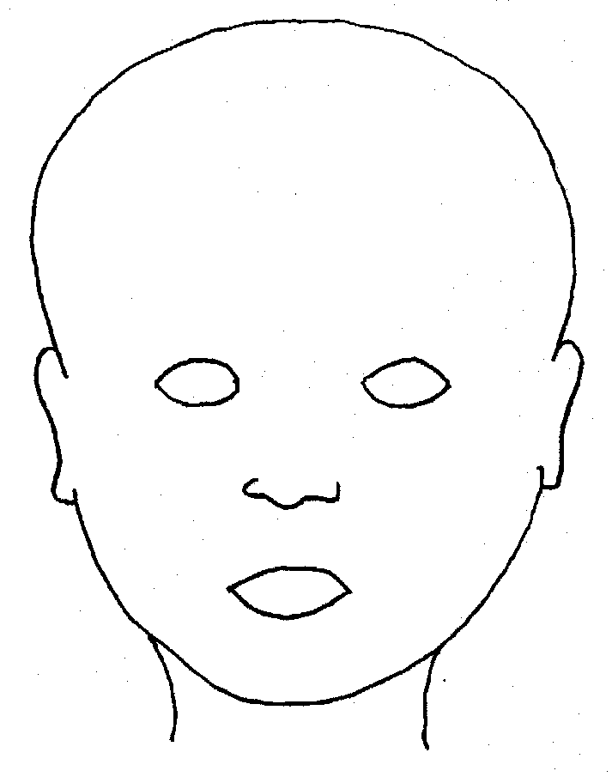
FRONT |  | BACK
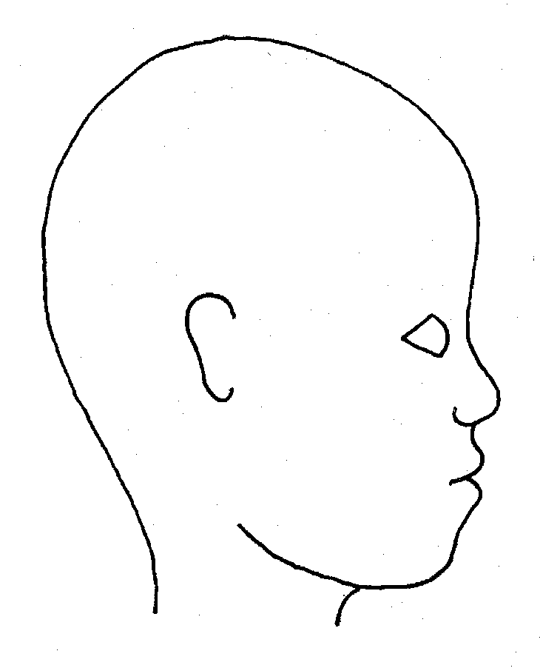 |  | 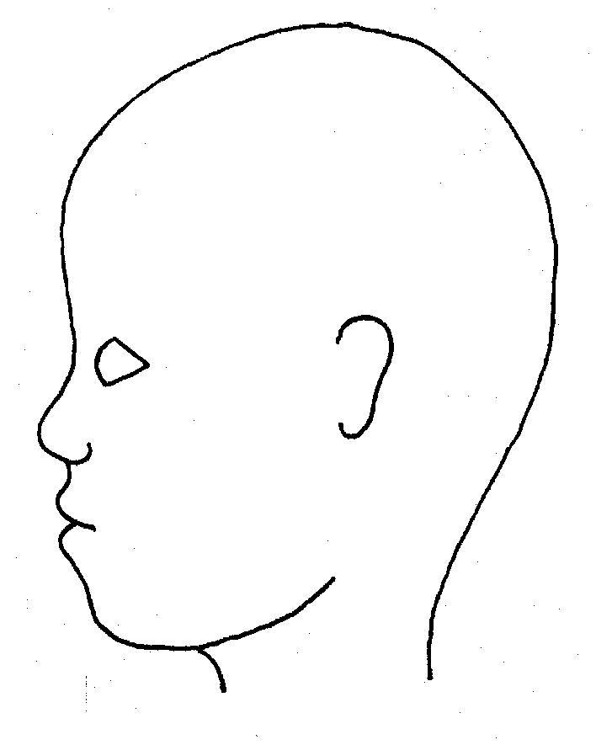
RIGHT |  | LEFT

Name of pupil: |  |  |  |  |  |  | Date and time of observation:
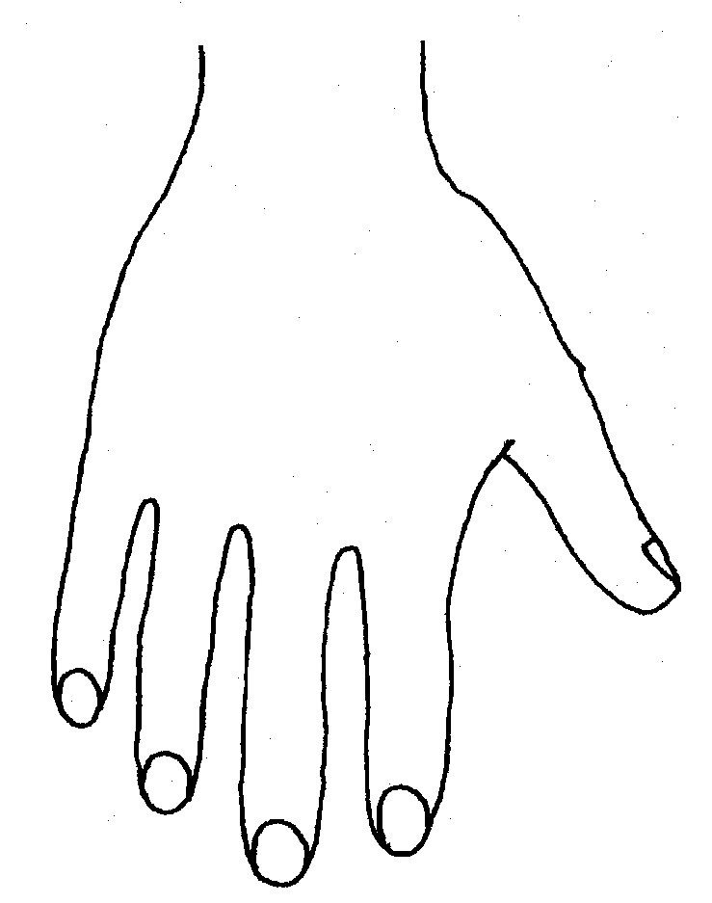 |  |  |  |  |  | 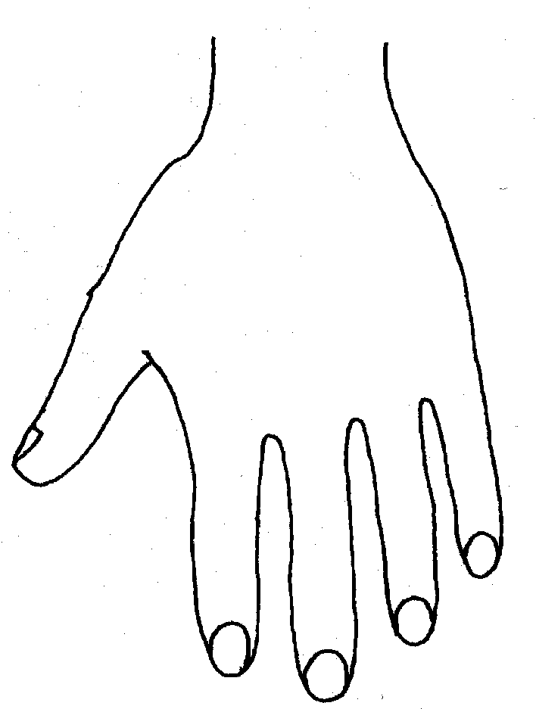
R |  |  |  |  |  | L
BACK
Name of Pupil: |  |  |  |  |  |  | Date and time of observation:
R | TOP |  |  | L | R |  |  | BOTTOM |  |  |  | L
R |  |  |  |  | L
INNER
R |  |  |  |  | L
OUTER
Printed Name, Signature and Job title of staff:

In maintained schools the governing body is responsible for ensuring their functions are exercised with a view to safeguarding and promoting the welfare of children in accordance with section 175 of the Education Act 2002, for pupil referral units it is the management committee, in independent schools, including academies and free schools this duty sits with the proprietor. References to the governing body throughout this policy framework includes management committees.
Section 175, Education Act 2002 – for management committees of pupil referral units, this is by virtue of regulation 3 and paragraph 19A of Schedule 1 to the Education (Pupil Referral Units) (Application of Enactments) (England) Regulations 2007
Please note that in accordance with Working Together to Safeguard Children 2018, Suffolk Safeguarding Children Board will be working towards transition to the new Safeguarding Partner Arrangements, which should be in place by July 2019. This policy will need to be revised to reflect the new arrangements.
N.B. The exception to this process will be in those cases of known FGM where there is a mandatory requirement for the teacher to report directly to the police, although the DSL should also be made aware.
National crime agency human-trafficking
Under Section 5B(11)(a) of the Female Genital Mutilation Act 2003, “teacher” means, in relation to England, a person within section 141A(1) of the Education Act 2002 (persons employed or engaged to carry out teaching work at schools and other institutions in England).
Section 5B(6) of the Female Genital Mutilation Act 2003 states teachers need not report a case to the police if they have reason to believe that another teacher has already reported the case.
As defined in the Government’s Counter Extremism Strategy
As defined in the Revised Prevent Duty Guidance for England and Wales
According to the Prevent duty guidance ‘having due regard’ means that the authorities should place an appropriate amount of weight on the need to prevent people being drawn into terrorism when they consider all the other factors relevant to how they carry out their usual functions.
“Terrorism” for these purposes has the same meaning as for the Terrorism Act 2000 (section 1(1) to (4) of that Act).
Legislation.gov.uk
It is important school and college staff (and especially designated safeguarding leads and their deputies) understand consent. This will be especially important if a child is reporting they have been raped, More information here
PSHE Teaching about consent from the PSHE association provides advice and lesson plans to teach consent at Key Stage 3 and 4.
Project deSHAME from Childnet provides useful research, advice and resources regarding online sexual harassment.

